**A B**

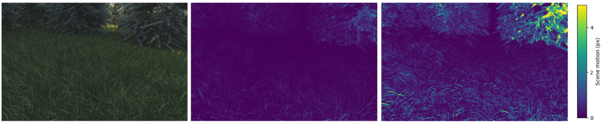

**A B C**

**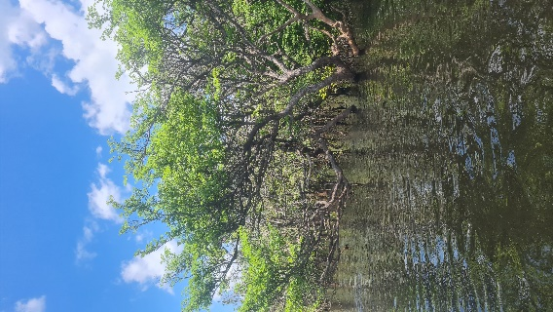 A B C D**

